Introduction
Using an Arduino with an MCP2515 module allows one to control a SPARK MAX and take advantage of the numerous built-in sensors and onboard PID controller.

Images
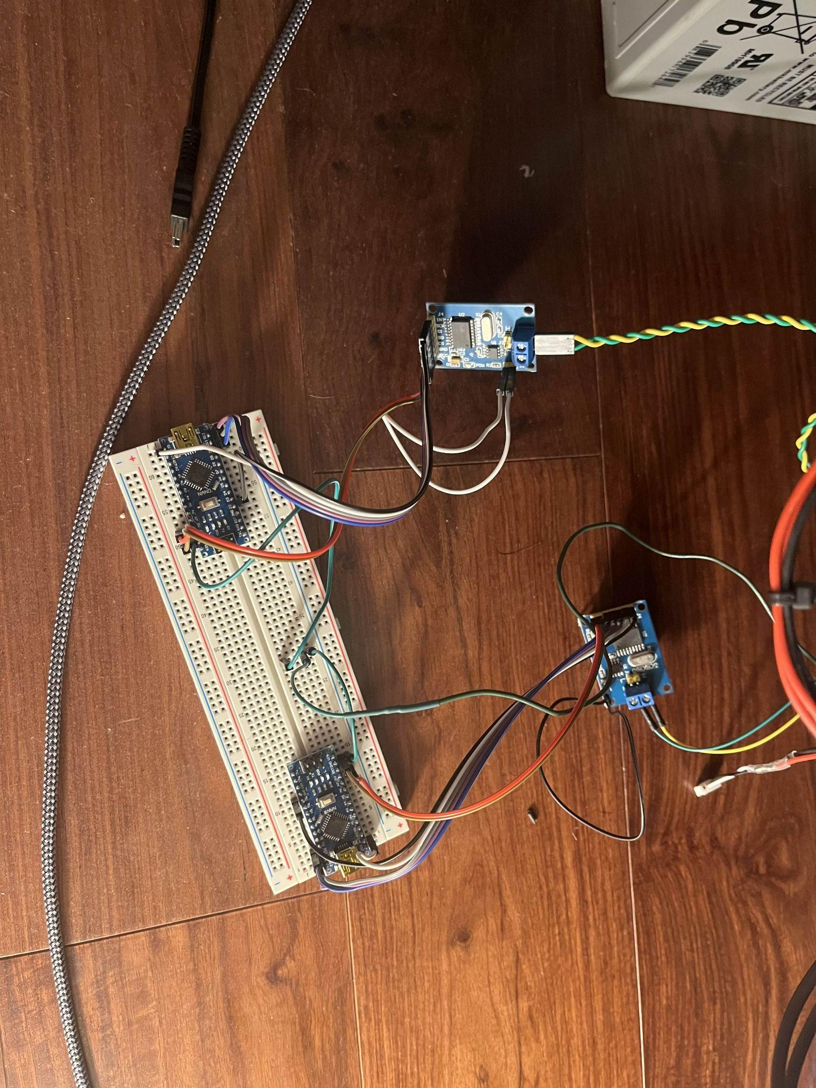
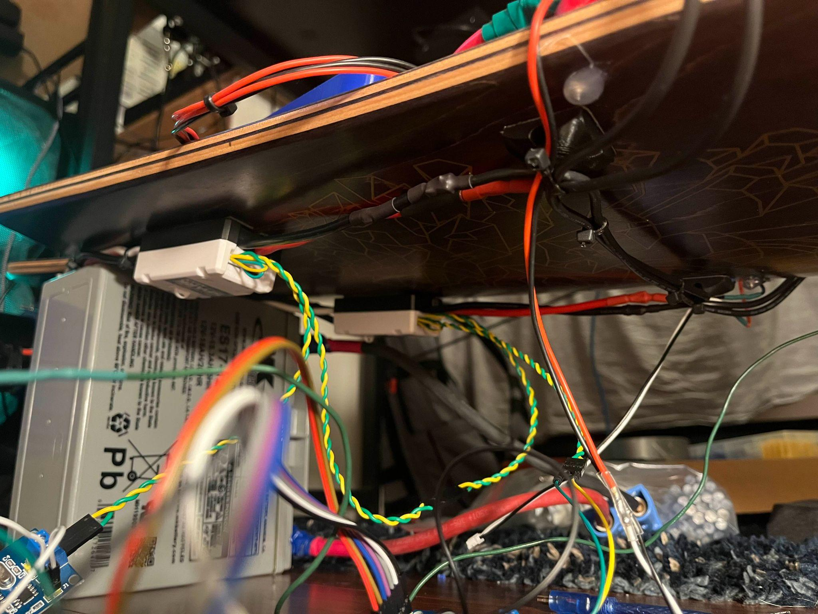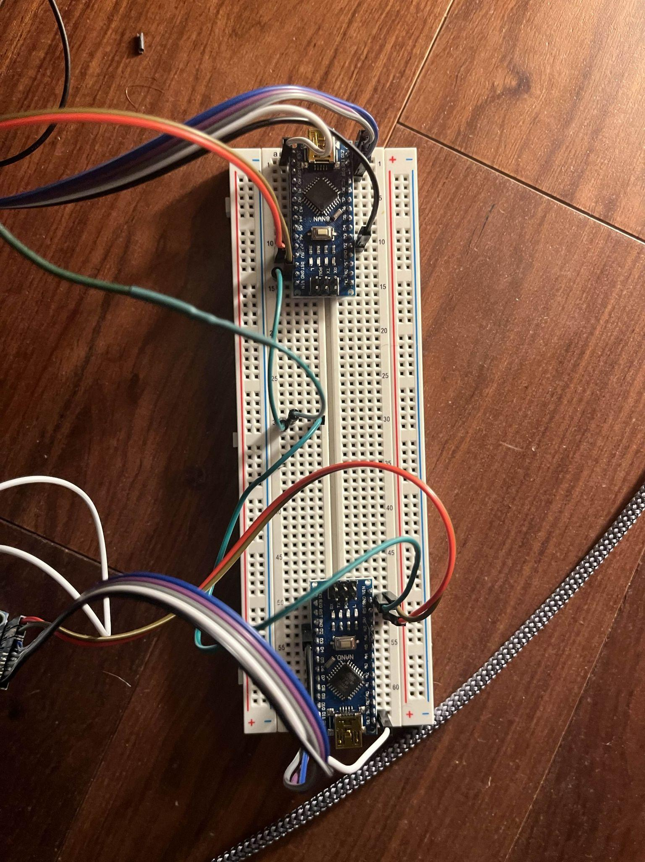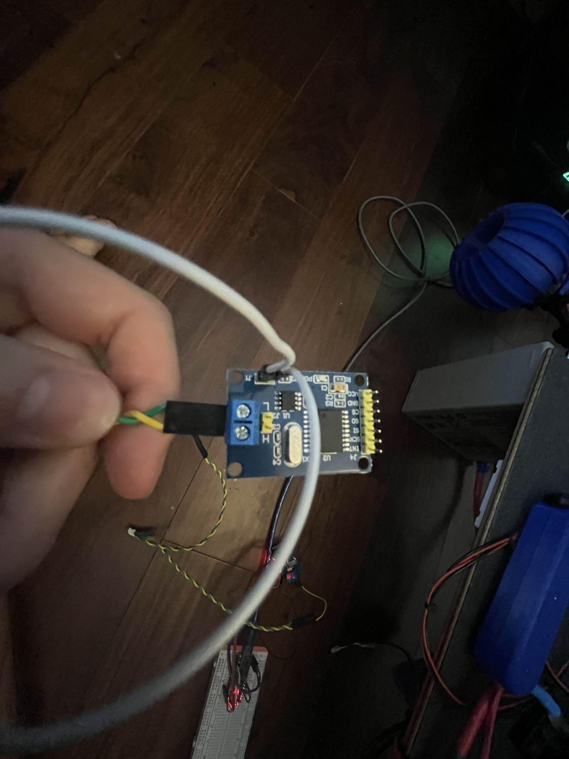

Helpful Links
- FRC CAN DEVICE SPECIFICATIONS:
- SPARK MAX CONTROL INTERFACES:
- MCP2515 CAN Library:
- SPARK MAX Parameters:
- SPARK MAX Commands Signals:
- SPARK MAX All Commands:
- IEEE Floating Point Calculator:

